Lecture 01

**AWS-CloudComputingOverview-AWS-GlobalInfrastructure**

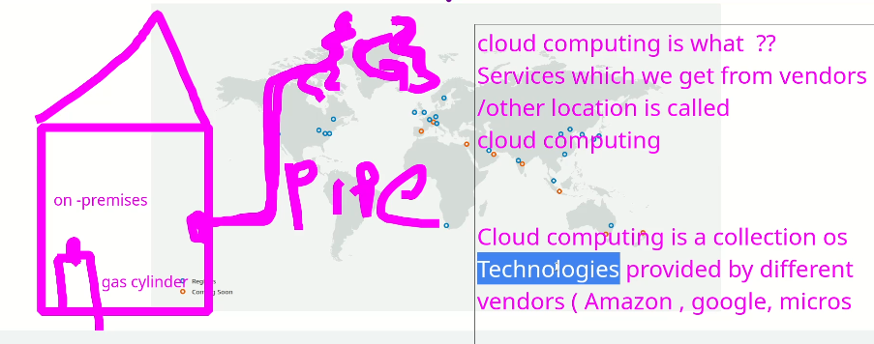

If a person Umar wants to build a company the infrastructure required is as shown below, itr is called on-premises.

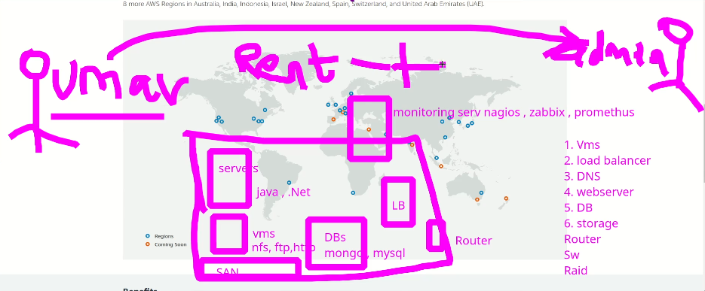the other way to handle is as shown below, à umar shifted few of his equipment to “NetMagic” and saved 20 Lakhs in cost.



* If the Data Centre is used it is called (co-location)
* Its is also called “Shared hosting”
* Or VPS (virtual Private Sharing)
* The idea (Data Centres) was initiated by Amazon,
* 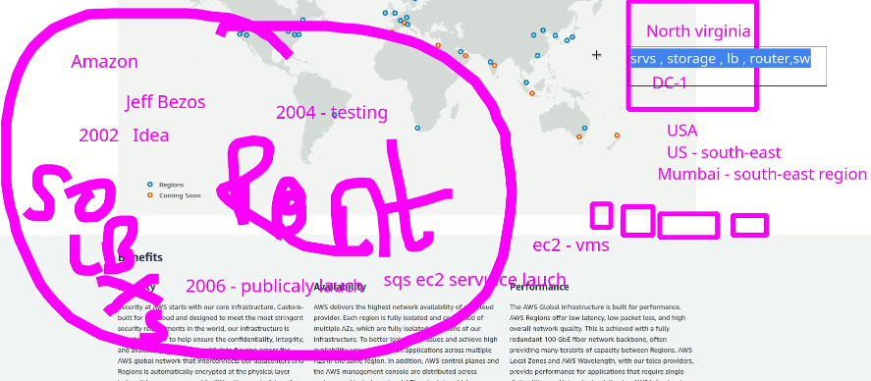
* Amazon named it CC or C2 (Cloud Computing) à IaaS, PasS, SaaS
* The equipment (Hardware, servers, routers, LB, switches etc.) provided by AWS is called **IaaS** (Infrastructure as a Service)
* AWS also provides **PaaS** (Platform as a Service) i.e OS, DB, Lambda Service etc.
* For monitoring software are also required which is called **SaaS** (software as a Service)
* There r more C2s Azure, GCP and Ali Baba.
* If a user uses more than 1 cloud services, à it is called hybrid cloud.
* The whole service can be built within 5 minutes as compared to months in case of on-premises.
* Different Data Centres in world’s different locations are called Availability Zones or AZ.
* Different locations in the world are called “Regions” --> regions can have multiple Data Centres or AZs.
* AWS--> Regions--> AZs
* These all are called **Global Infrastructure.**

Cloud computing, including services like Amazon Web Services (AWS), offers several advantages to businesses and individuals alike. Here are some of the key benefits:

1. Scalability: Cloud computing allows businesses to quickly scale up or down their computing resources based on their needs. This means that businesses can easily adapt to changes in demand, which can help them save money on infrastructure costs.
2. Cost savings: Cloud computing eliminates the need for businesses to purchase and maintain expensive hardware and software. Instead, businesses can pay for the computing resources they need on a pay-as-you-go basis, which can result in significant cost savings.
3. Flexibility: Cloud computing allows businesses to work from anywhere and on any device, as long as there is an internet connection. This can be especially useful for remote teams or businesses that have multiple locations.
4. Security: Cloud providers like AWS offer high levels of security and data protection, which can give businesses peace of mind. Additionally, cloud providers typically have more resources and expertise to devote to security than individual businesses do.
5. Reliability: Cloud providers like AWS offer high levels of uptime, which means that businesses can rely on their services to be available whenever they need them. This can be especially important for businesses that rely on their computing resources to operate.

Overall, cloud computing can provide businesses with greater flexibility, cost savings, and scalability than traditional computing methods, which can ultimately help them be more competitive and successful in their respective industries.